**Question 3.** (ainda por testar)

SELECT Patient.name, Reading.value

FROM Patient, Reading, Sensor

WHERE Reading.value > 200

and Sensor.units = 'LDL cholesterol in mg/dL' and DATEDIFF(Reading.datetime, NOW()) < -90;

---Alternativa---

SELECT Patient.name, Reading.value

FROM Patient NATURAL JOIN Wears NATURAL JOIN Device NATURAL JOIN Reading NATURAL JOIN Sensor

WHERE Reading.value > 200 and Sensor.units = ' LDL cholesterol in mg/dL ' and DATEDIFF(Reading.datetime, NOW()) < -90;

---Relevant Links---

DATEDIFF() -> [link](https://www.w3schools.com/sql/func_mysql_datediff.asp)

NOW() -> [link](https://www.w3schools.com/sql/func_mysql_now.asp)

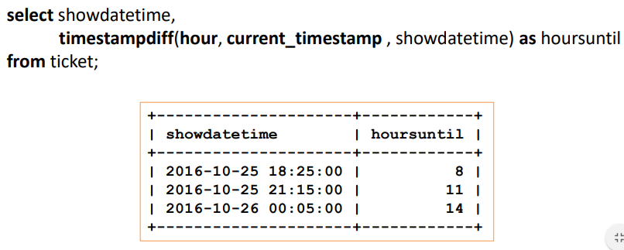An alternative from the slides:

TIMEDIFF() is similar to DATEDIFF() but for hours instead of days.

TIMESTAMPDIFF() can be used for: FRAC_SECOND (microseconds), SECOND, MINUTE, HOUR, DAY, WEEK, MONTH, QUARTER, or YEAR

**Question 4.** (divisão de conjuntos; usar sub-queries) (ainda por testar)

SELECT Patient.name

FROM Patient

WHERE Patient.number IN (SELECT Wears.patient

FROM Wears

WHERE Wears.manuf = 'Medtronic' and DATEDIFF(Wears.end, NOW()) > -365);